*You represent the farmers in developed nations, such as the US and Canada. These are the large farms that are operated by families, not by large agribusinesses.*

**Background Information:**

* Approximately 97% of U.S. farms are operated by families, individuals, family partnerships or family corporations.
* Farm and ranch families comprise 2% of the U.S. population, but 21+ million Americans (15% of the U.S. workforce) produce, process, and sell the nation’s food and fiber.
* 87% of farms are considered small farms, selling less than $50,000 per year. 8% are large farms and 4% are multibillion dollar agribusiness farms.
* Today’s farmers produce 262% more food than in 1950, using less labor, seeds, feed, fertilizer, etc.
* The U.S. sell more food and fiber to world markets than we import, making a positive agriculture trade balance that boosts the economy.
* Farmers and ranchers only receive 16 cents/dollar spent on nationwide food at home and away from home. The rest goes for wages, materials, processing, marketing, transportation, and distribution. That’s 15 cents less per every dollar than received in 1980.
* Americans enjoy a food supply that is abundant, affordable, and one of the world’s safest for consumers.
* More than half of America’s farmers intentionally plant trees or build in conservation buffers to improve soil, water quality, and provide habitat for wildlife.
* Modern farming practices help prevent soil erosion and are more environmentally and energy friendly.
* American farmers fully support practices that enable them to reduce pesticide use by using as much natural pest enemies and crop rotation as much as possible.
* Nearly 30% of today’s farmers have attended college and over half of these have four year degrees.
* Since WWII, the industrialization of farming has been promoted, asking for specialization, standardization, and consolidation of control to encourage greater economic efficiency.
* Many smaller farmers were being bought out by larger factory farms, but these companies are finding it more profitable to move overseas, where land is inexpensive, government policies favor big business and labor is cheap.
* Benefits of industrialized farming are declining and many family farmers are beginning to realize that a crisis in agriculture is happening and is not due to another period of chronic oversupply, but from American agriculture going under corporate control. The family farmer is starting to “fight back” and is evolving into “new farmers.” They are creating new and better ways to farm through organic, biodynamic, holistic, ecological, natural, practical, sustainable farming.
* The U.S. government provides monetary subsidies to large agricultural companies to grow cereal crops, which are cheap, nutritionally poor, and easily exportable. However, farmers of fruits and vegetables receive either none or very little of these government subsidies making their produce much more expensive and less accessible for many people.

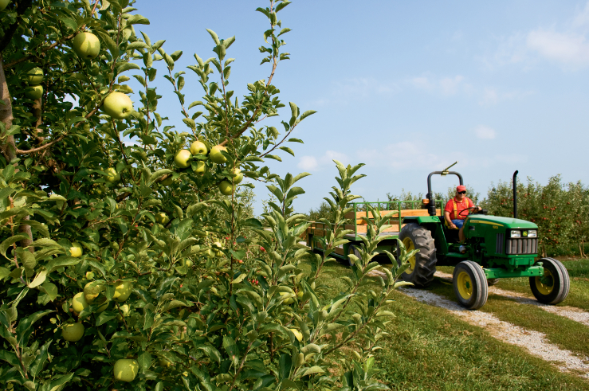

<http://farmflavor.com/wp-content/uploads/2013/06/7530808JWA3469.jpg>